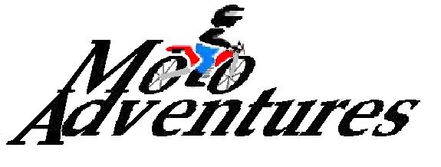

WAIVER AND RELEASE OF LIABILITY AND ASSUMPTION OF RISK

By signing this form you give up your right and your family’s right to bring a court action to recover compensation for any injury to your property or to yourself, including that which results in your death. By signing this form you are assuming both physical and legal risks that have potential financial implications for yourself and/or your family should you be injured or killed while participating in any Lovier’s Moto Adventures activity. By signing this form I understand and agree that the foregoing Waiver and Release of Liability and Assumption of Risk is intended to be as broad and inclusive as is permitted by the laws of the State of California and that if any portion thereof is held invalid, it is agreed that the balance shall continue in full and legal force and effect.

I HERBY ACKNOWLEDGE AND AGREE that:

- The activities organized by Lovier’s Moto Adventures have inherent risks and I have full knowledge of the nature and extent of the risks associated with these activities.
- The owners, agents, or employees of Lovier’s Moto Adventures are not responsible for my safety. Other members participating in Lovier’s Moto Adventures activities are not responsible for my safety.
- I could suffer serious physical injury or even death as a result of participating in the activities organized by Lovier’s Moto Adventures.
- I am at least 18 years of age. Lovier’s Moto Adventures will not allow me to participate unless this Waiver and Release of Liability and Assumption of Risk form has been read and signed by me. Lovier’s Moto Adventures will not permit me to bring a child on any activity and each adult must sign his/her own Waiver and Release of Liability and Assumption of Risk form.
- I agree that while participating in this activity I will conform to all state and federal laws. I also agree to accept and follow the directions of the owners, agents, and employees of Lovier’s Moto Adventures. I agree to act in a mature, responsible and respectable manner, deemed as such by Lovier’s Moto Adventures and will follow all wilderness regulations and ethics. I understand that failure to do so may result in a breech of contract and my participation with Lovier’s Moto Adventures can be terminated with no refund.
- I agree not to leave the group unless first notifying the activity leader.
- I hereby grant permission for the performance of any emergency medical treatment that may be required in the case of an accident wherein I am rendered unconscious or unable to approve of the required medical treatment. In the event that I become the victim of an accident I will hold harmless Lovier’s Moto Adventures from any liability in connection with the search and rescue, stabilization, evacuation, transportation, and emergency care I receive while secondary aid resources are being sought.
- I hereby agree to permit Lovier’s Moto Adventures owners, agents, employees, and other guests to take photographs and make film records of the trip or of me without further recourse. I understand and agree that such photographs and/or film may be used for commercial and/or promotional purposes.

I agree to the non-refundable deposit of $__________, which will be applied to the cost of $___________ per tour.

____________________________________________________________________________________
Rider’s signature Print Name DL # Date

